**BOUTIQUE SHOP MANAGEMENT SYSTEM**

**A SYSTEM RESEARCH PROPOSAL**

**SUBMITTED BY,**

**MWAMRIZI TIMOTHY KARINGO**

**DSE-01-1341/2021**

**A RESEARCH PROPOSAL SUBMITTED IN PARTIAL FULFILMENT FOR THE AWARD OF A DIPLOMA IN SOFTWARE ENGINEERING BY ZETECH UNIVERSITY**

**NOVEMBER,2022**

**TABLE OF CONTENTS**

**DECLARATION** i

**ACKNOWLEDGEMENT** ii

**DEFINITION OF KEY TERMS** iii

**ABBREVIATIONS AND ACRONYMS** iv

**ABSTRACT** v

**LIST OF FIGURES** vi

**LIST OF TABLES** vii

**CHAPTER ONE: RESEARCH INTRODUCTION** 1

**1.1** **Research problem** 1

**1.2** **Research Objectives** 1

**1.2.1** **General Objective** 1

**1.2.2** **Specific Objectives** 1

**1.3** **Background Information** 1

**1.4** **Study Justification** 1

**1.5** **Study Limitation** 1

**1.6** **Problem Scope** 1

**CHAPTER TWO: LITERATURE REVIEW** 2

**2.1 Introduction** 2

**2.2 Theoretical Review** 2

**2.3 Empirical Review** 2

**CHAPTER THREE: SYSTEM METHODOLOGY AND DATA COLLECTION** 3

**3.1 Introduction** 3

**3.2 System Requirements Specification** 3

**3.2.1 Functional Requirements** 3

**3.2.2 Non-Functional Requirements** 3

**3.3. Design** 3

**3.3.1 Low Level Design** 3

**3.3.2 High Level Design** 3

**3.4 Implementation / Development** 3

**3.4.1 Language(s), Frameworks and Other Technical Requirements** 3

**3.4.2 Code Review Strategy** 3

**3.5 Testing** 4

**3.5.1 Functional Requirements Testing** 4

**3.5.2 Non-Functional Requirements Testing** 4

**3.6 Deployment** 4

**CHAPTER FOUR: CONCLUSION AND RECOMMENDATIONS** 5

**4.1 CONCLUSION** 5

**4.2 RECOMMENDATIONS** 5

**CHAPTER FIVE: REFERENCES AND APPENDICES** 6

**5.1 REFERENCES** 6

**5.2 APPENDIX I:** 6

**5.3 APPENDIX II:** 6

**5.4 APPENDIX III: GANTT CHART** 6

# **DECLARATION**

I Mwamrizi Timothy Karingo declare that this proposal is my original work and has not been presented to the award of a diploma in any university or any other award.

SIGNATURE: DATE:

NAME : Mwamrizi Timothy Karingo

REG NO : DSE- 01-1341/2021

SUPERVISOR’S APPROVAL

I confirm that the work reported in this proposal will be carried out by the candidate under my supervision and has been submitted with my approval as the university supervisor.

SIGNATURE:

DR. DATE:

Department of ICT and engineering

**ACKNOWLEDGEMENT**

I am most grateful to God as this has been a task but I did it.

To my supervisor, I would like to express my sincere gratitude and appreciation for his continued support, generous academic advice, discussions, suggestions, encouragement and guidance.

To my best friends, thank you for your support and encouragement.

To my parents too may God bless you all.

God bless abundantly

**DEFINITION OF KEY TERMS**

Software – set of instruction, data or programs used to operate computers and execute specific

Tasks

Boutique – a shop selling fashionable clothes or accessories.

Management system – set of policies, processes and procedure used by organization to ensure

That it fulfils task required to achieve its objectives.

Accessories – things can be added to something else in order to make it attractive.

Framework – tools that help professionals build app, website and digital systems.

Administrator -someone who can change security settings, access all file on the computer and

make changes to the other users.

Cart – a piece of software that facilitates the purchase of a product or service.

Store manager – is a professional who is responsible for overseeing the daily operation of their

store, making sure it runs smoothly and effectively

**ABBREVAITIONS AND ACRONYMS**

SRS – Software Requirement Specification

DMP – Data Management Platform

SaaS - Software as a service

HTML – Hypertext markup language

MySQL – Structured query language

PHP – Hypertext Preprocessor

ADMIN – Administrator

DBMS – Database Management System

**ABSTRACT**

A boutique is a shop that deals in fashionable clothing or accessories, while management system is a software web-based application which the organization will manage the interrelated parts of its business in order to achieve its objectives. A management system is a key tool in helping to streamline your business processes and build-in efficiency. Boutique system is a type of e-commerce which takes place between an organization and their customers, providing online selling activities as well as online financial transactions. The system maintains the report of placing orders and delivery details, customer details, branch offices details and working staff details and store to the database. This service is necessary and important to the society, as it has helped solve large number of problems. The modules include placing orders and delivery, delivery, customer details and their respective database. The advantage of this system created it can search for bar codes and search according to attributes, if the item has been purchased. Code let you use that instead of creating unnecessary complications, also allows multiple tenders in one single payment by summing up all product costs thus saving time and other resources.

Boutique system can block all sales if inventory is zero meaning you don’t have to of item already sold. boutique of course offer free delivery and percentage discount this intern benefits its customers.

One of the disadvantages is if its not popular it may be risky and may not offer maximized profit and maybe a waste of resources and time. When one opens a boutique, two achievements must be made and that is profit and being able to manage and put everything in control.

Designing and developing the system also is very crucial. You have to consider things like data requirement, program specification, framework and the DBMS of the system to make sure the final product meets the standards of software development process and your customer preference at large because they are the one who will impact positively or negatively. The system meets system requirement specification where functional and non-functional requirement are fulfilled by the website and test them to make sure each feature works as per the requirement. Finally deploy your system application to the customers knowing very well it has met every standard. After delivering to the users, the task you remaining with is management, updating your software, respond to customers preference and adding new features, also ensuring compliance with the software rules, term of service and other thing because it’s a business laws must be followed. A business must be licensed.

**LIST OF FIGURES**

**Figure 1:** Use Case Diagram…………………………………………………16

**Figure 2:** Class Diagram……………………………………………………..17

**Figure 3:** Sequence diagram………………………………………………....18

**Figure 4:** Activity diagram…………………………………………………..19

**LIST OF TABLES**

**Table**: Development process…………………………………………….27

**CHAPTER ONE: RESEARCH INTRODUCTION**

**1.1 Research problem**

Approximately 70% of world boutique retailors have moved from the old outdated ways of selling and managing their shops, back then customer had no option but to visit a boutique shop even if you had to travel for long distance only to get what you wanted to satisfy your needs. They have adopted new trends and this is due to the fast and rapid changing technology where system of boutique shop has been created furthermore the boutiques themselves are practicing what we call specialization.

This web applications which have help and changed everything and have made work easier, helping major online activities and secured transaction. This can reduce man power and open new business opportunities. Boutique shop management system, saves time and manage commodities way more efficiently.

**1.2 Research objectives**

**1.2.1 General objectives**

The study is aimed to develop fashion products system for keeping product details, billing details using computerized process.

**1.2.2 Specific objectives**

Analyzing the E-payments and customer relationship management on the website.

Identify customer trends and what they want.

Monitor the system and making sure it updated and working properly

**1.3 Background information**

A Boutique is a shop that deals in fashionable clothing or accessories. In the late 1990’s, some European retailors developed an idea called “Concept Stores”. Boutique appeal to customer due to their level of specialization. Entrepreneurs open a Boutique business as it allows them to focus on their expertise, most Boutiques comprises of clothing, whether the Boutique business is in the planning stage or already established, their marketing plan is based on social medias, television and newspapers. Boutique systems which is E-commerce take place between organizations and their customers (Whitley, 2000), White Koty 2006) *E-commerce is the process of managing online financial transactions and providing online selling activities.* With the increase 0f online shopping and application.

In the research of (Dennis Et Al 2009) Consumer behaviors, perception of risk and benefits, demographic of consumer and psychological characteristics are technical oriented which means specification of an online store, Interface design and navigation, payment and information has intended us and the ease of use.

**1.4 Study** **Justification**

The study is based on independent retailers who are on the rise and they are making more money doing with E-commerce and fewer physical location. Boutique management have doubled in the past years. Customers care about the experience from how they order the product to how its delivered in time and how it makes them feel, also Boutique system are showing its customers new trends and this leads them to buying and sharing services. Social media keeps on showing the capabilities of boutique management system like giving off discount. These and many more make us curious and makes us study more and analyze about boutique in general.

**1.5 Study Limitation**

* Since the system is implemented in manual so the response is very low.
* Offline reports cannot be generated due to batch mode execution.

**1.6 Problem scope**

The proposed system problem scope is to record the details of various activities of user, appropriate training to suit specific needs. The cost of managing the boutique management system from workers, accounts, finance and the system itself is stressful enough and if not properly managed it cost useful resources and time.

**CHAPTER TWO: LITERATURE REVIEW**

**2.1 Introduction**

The Boutique management system is useful to all type of boutique shops. By using this project, we can maintain the reports of placing orders and delivery, customer details, branch office details and working staff details. Boutique service is important for the society. They distinguish from ordinary to expensive by features as advanced techniques of perfect fashion tailoring, specialization and individualization of services and committed delivery time, which are optional for most everyday services and their use typically restricted to the type of orders where one or more of these features are considered important enough to warrant the cost.

Different boutiques service operates on all scales, from which specific town or cities to regional, national and global services operate on all scales. Here we design the project which involves the following database;

1. Placing orders and delivery details
2. Delivery status
3. Customer details
4. Branch office details
5. Employee details

The database keeps record of all sorts of information that is from customers name, delivery reports and date, personal staff names and addresses, mobile numbers that will be used. The data is very useful to every boutique shop out there.

When opening a boutique, you as an IT or businessman first thing you want to achieve is profit, having large amount of investments, outdo others and come out as independent surviving shop and defeat the available competition in the market. Organization’s want to ensure they are the most trusted companies when it comes to delivery services and maybe discount option. Most boutique sell clothes, so you as the manager should have clothing of people of all ages, size, gender, styles and preference.

Advantages of boutique shop management system, some of the features of retail point of sale system software are. Boutique can search for bar codes and search according to attributes, if the item has been purchased with an OEM code, it let you use that instead of creating unnecessary codes and complications. Multiple tenders in one single payment thus saving time and other resources. Boutique system can block all sales if inventory is zero, meaning that you never have to care of item sold in inventory or not. Multiple stores located at different regions serving the same customers because the system is the same thus customers save their money and time because of short distance delivery. Boutique have free delivery and discount services on their products.

The disadvantage related with the system access to the market offering product or service to only a small portion of the population make it risky, unless its internet-based.

**2.2 Theoretical Review**

Despite economy growth, hundreds of stores are closing. Recently it has been disastrous for all and it touched everyone. The reality is total spending continues to grow steadily, despite trends of industry, growth of e-commerce. The excess of shopping centers and other business have led to the factor that boutique is not doing well. Sustainability, sustaining brands name, quality of their products, if the name of brand is related to any negativity it will be badly impacted. If the supply chain department fails to deliver or fulfil its services, people may go to another stores. The number of boutique store may decrease as consumer spend more time on travel and restaurant, one may have wasted part of his resource and time to create a system only for other factors to fail him.

An IT or store operators look at how to solve current and future challenges. Having the right number of employees at given time, making sure there is right number and variety of product from one order cycle to the next although its not guaranteed thing will like this all the time. Consistently respond to all demand, for any decent sized store, combining real time data and alerts with the best practice guidance of action. If store could do that, they could maximize sales, lower expenses, improve customer services and compete better and maybe so their future for surviving and making it to e successful will be promising.

**1.2 Empirical Review**

The boutique management system to fulfil the requirement of the system. The system is divided into different modules each to perform their work accurately. When first introduced computer-based information systems were controlled by third parties that the retailer hired to do analysis. This was also due to the size of rudimentary computers that could take up an entire room and require teams to run them. As technology advanced, these computers were able to handle greater capacities and therefore reduce their cost. Smaller, more affordable minicomputers allowed larger businesses to run their own computing centers in-house and the began to decentralize the computing power from large data centers to smaller. In the value shop, activities are scheduled and resources are applied in a fashion that is dimensioned and appropriate to the needs of the client’s problem, while a value chain performs a fixed set of activities that enables it to produce a standard product in large numbers. The value shop is a company that creates value by solving unique problems for customers and clients. Knowledge is the most important resource, and reputation is critical to firm success.

Talking about experiences, the smallest solution can be utilized for a simple experience installation for eye catching promos this is the efficient way to produce scalable supplies throughout the entire store and the entire store network. A full experience management solution is needed for good advertisement and themes, set of standards. This solution combines various digital surfaces, audios, themes and design. For example, a boutique needs large LE-walls, decorated walls and floors and lastly photos of products should be high quality captured in every angle to make sure customer view and examine the product.

**CHAPTER THREE: SYSTEM METHODOLOGY AND DATA COLLECTION**

**3.1 Introduction**

Data is the one of the most valuable resources today’s businesses. The more information you have about your surroundings from management to your customer, you understand better the interest, wants and the needs. One of the most crucial tools for collecting data is the Data Management Platform (DMP). We have two types of data collection, primary and secondary data, where primary data collection is which, you collect yourself or rather the first-hand data which is obtained directly from the source. Secondary data is the data already record and is available in journals, libraries or internet.

**3.2 System Requirement Specification**

**3.2.1 Functional requirements**

The primary requirement that are fulfilled by our website. Allows the user, customer to the website at a level of ease. The purpose is to provide the full information that is required by the user.

**USER**

**User Login** This feature will be used by user/admin to login into system. A user/admin must login with his username and password to the boutique system after registration. If they are invalid, the user is not allowed enter the system. Username and password will be provided after the user registration is confirmed and password should be hidden from others.

**Register New User** A new user will have to register in the boutique shop management system by providing essential details in order to view the whole system, the admin must accept new user by unblocking him. The system must encrypt user password for security purpose.

**Add To Cart** The user can add the desired garments and clothes as the product into his cart by clicking on the cart option and the product. He can view his cart by clicking on the cart button also remove an item from the cart by clicking remove. After confirming the items in the cart, the user can submit the cart and providing a delivery address. On successful submitting the cart will become empty.

**Search for boutique products** The user can search the desired product, view the description of the boutique. After confirming the items in the search user can select it into the cart.

**Reviews and requirements** The user can comment on the services also upload requirement of design and customizing to be made for their own satisfaction.

**ADMINS**

**Manage Users, Boutique System** The administrators can add user, delete user, view user. Can add the shop products, delete, hide or view them.

**Manage Orders** Administrators can view orders, update and delete orders. The system must identify the login of the admin and secure accounts

**3.2.2 Non-Functional Requirements**

**Efficiency**

When an online dress is bought online and delivered to the home of a customer after he has purchased. This makes the system efficient because no one has to go to the market.

**Reliability**

The boutique management system should provide a reliable environment and ease of use. Also deliver product to the right customer.

**Implementation**

Implement system using Bootstrap, CSS, ASP, PHP and HTML for database connectivity developed by SQL. Responsive web designing for making website compatible for any type of screen.

**Database Security**

Unauthorized personnel cannot access the panel and database, read and write information because it will temper and bring confusion like workers details database.

**Availability**

The boutique shop management system must be available at least 24 hours a day and customers can make any orders at any time.

**3.3 Design**

**3.3.1 Low Level Design**

Low level design involves detailed components. It may include object-oriented design, UML diagrams like use case, class, activity and sequence diagrams which show detailed system in visual perspective. Database design, all this identifies all modules of the system and the logic of designing the software application.

**Use Case Diagram**

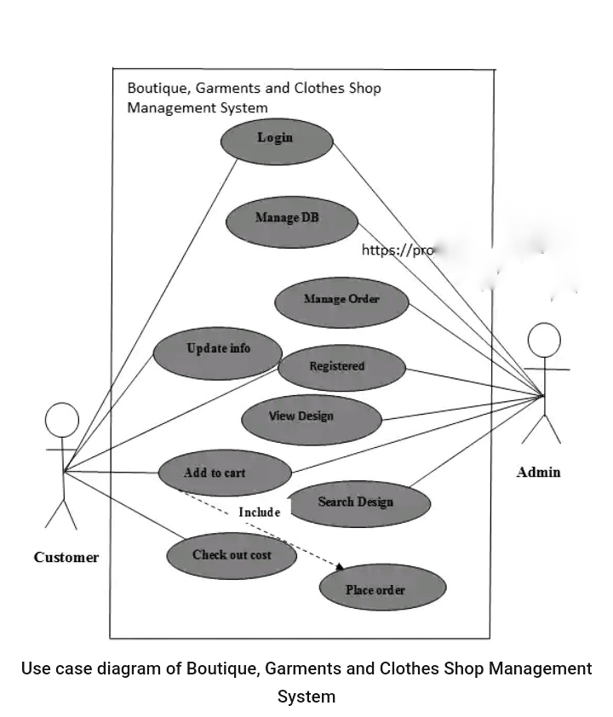

**Class Diagram**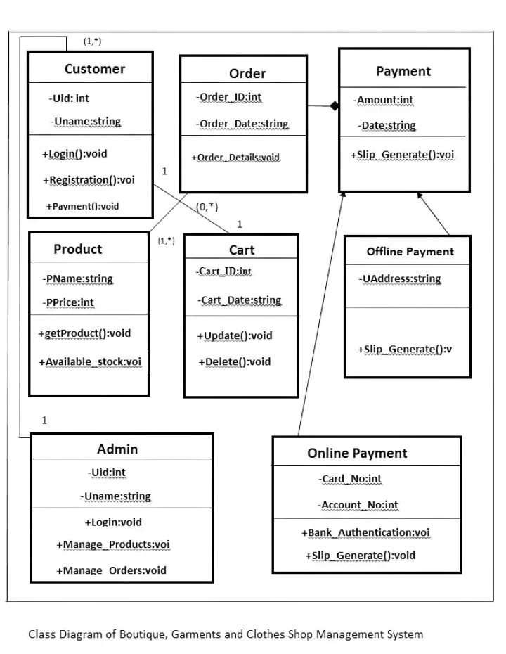

**Sequence Diagram**

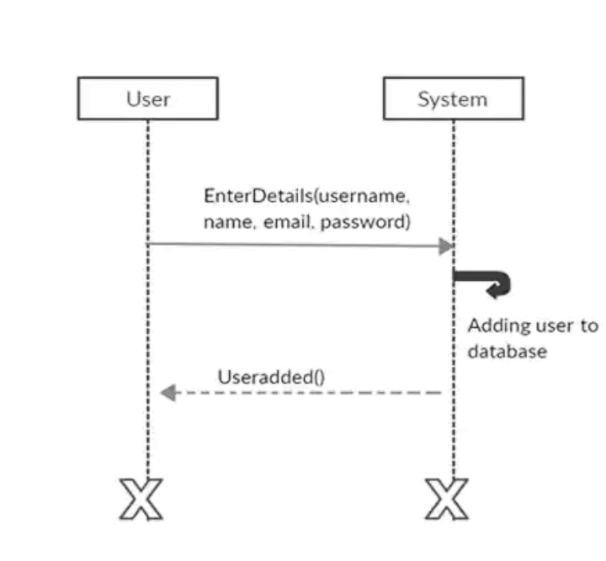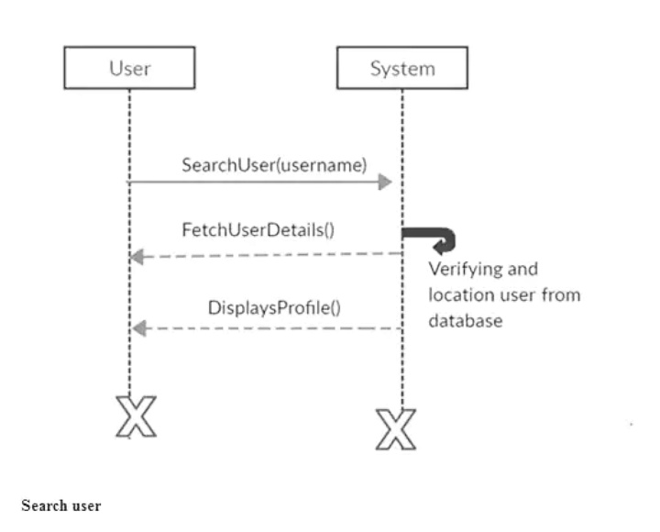

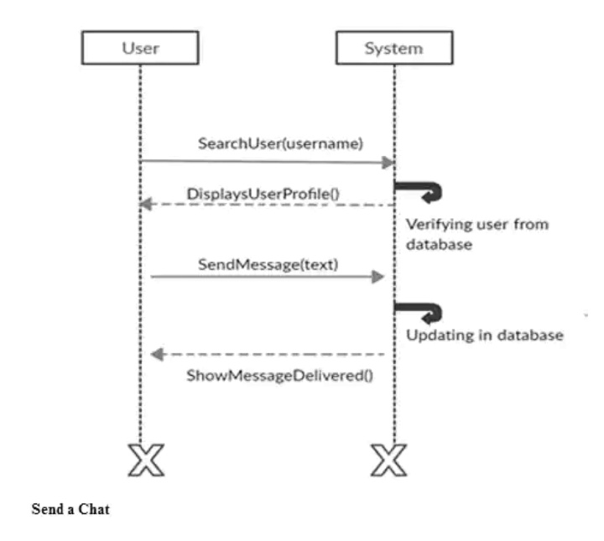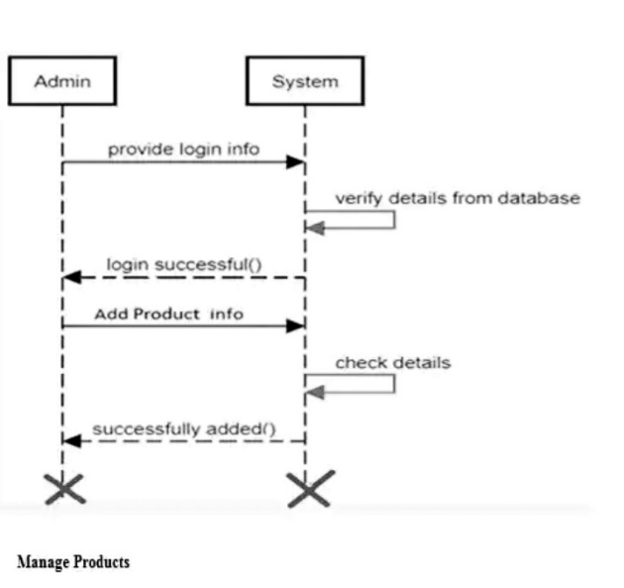

**Activity Diagram**

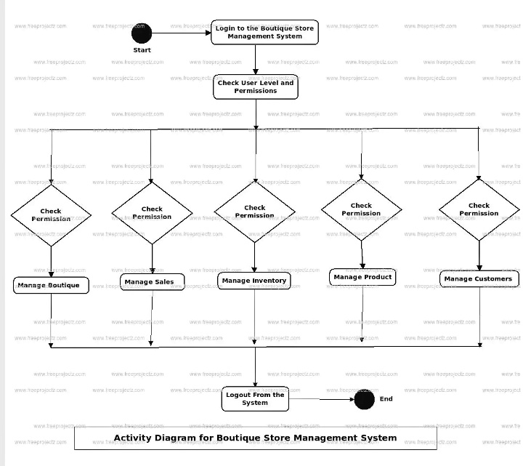

**3.3.2 High Level Design**

Generally, it includes the description of a system architecture and design, explanation of components like system, services and the process. Data flows and data structures to understand better the system. Components include attributes and functionalities.

**Architectural design** Boutique management system to fulfil the requirement of the system and developed according to the needs of a system. The system is divided into different modules to perform their work correctly and to explain those requirements are related to each other. Grouping of data, identify and develop the model DFD

**System structure chart** whichshows all process of the system and relationship between the process.

**Program specification** procedures that the user will follow to implement the system it includes set of program specification, program overview, screen layout and report design using various tools like –

Visual studios.

Net framework

Net framework basically works as a platform to execute different languages. Designing the system using MySQL and PHP. HTML and JavaScript application packages. Choosing a suitable lifecycle model and developing a website prototype and evolution the finished product.

DBMS of the system which includes customer, garments, supplier database, report generation database, bill generation, sales database etc.

**3.4 Implementation/ Development**

**3.4.1 Languages(s), Frameworks and Technical requirements**

The boutique system is an automated system that is developed using SQL server and Visual studio and . Net framework executes different language to implement the system, it include complete set of program specification and related report design.

Technical requirement like hardware and software.

Software requirement include-

Windows

Windows 8 and above

Hardware requirements include-

RAM 2 GB

ROM 128GB and above

Processer: Pentinum V, Core

Technologies used-

MySQL is an open-source relational database management system.

**3.4.2 Code Review Strategy**

The system coding and testing stages need convening with my fellow programmers to check for code mistake that may have occurred to correct and accelerate the process of software development. This is important as it saves money particularly by catching the type of bugs that might slip undetected through testing, production and into the end user laptops, where upon those annoyed customers will issue scratching reviews of your products and your sales will suffer accordingly. By programmers coming together to solve software problems, it also provides more knowledge and better ways to write a clean code, solve common problems with useful shortcuts. Making it easier for an organization to curate, govern and manage the lifecycle of digital artifact beyond the source code. Taken together, these factors should inspire any development team to consider implementing a smart, strategic code review process. For sure creating a system should be done by two or more group of programmers because there is potential to foster a great working system.

**3.5 Testing**

**3.5.1 Functional Requirements Testing**

Functional requirement testing seeks to establish whether each application feature work as per the software requirement. Each function compared to the corresponding requirement to ascertain whether its output is consistent with the end user expectation, example is;

Can the user successfully login into the application once they provide legitimate credentials.

Does the payment gateway reject the input and display an error message when user keys in invalid information.

Do input to the screen successfully add and save new information to the database.

In the end of functional testing, you should have a software that has a coherent user interface, a consistent API and seamlessly integrates with the process.

**3.5.2 Non-Functional Requirement Testing**

Test is used to evaluate software application performance, usability, dependability and other non-function character, the Software Requirement Specification (SRS) serves as the basis of this software testing method, which enable quality assurance team to check if the system complies with user requirement, increasing it aid in lowering the manufacturing risk associated with the products non-functional components.

**3.6 Deployment**

Software development include all of the steps, processes and activities that are required to make a software system or updates available to its intended users. Most IT software developers deploy software updates, patches and new application with a combination of manual and automated processes. Application, modules, updates and patches are delivered to the users, where they impact how fast a product can respond to the changes in customer preferences and quality of each change. Creating new paradigms to meet the changing demands of customers. The system will be a web-based (SaaS), also will use DeVOps which is a methodology and a set of best practices for software development whose primary goals are to shorten delivery times for new software while maintaining high quality.

**CHAPTER FOUR: CONCLUSION AND RECOMMENDATIONS**

**4.1 Conclusion**

The boutique system is a business just like any other, one needs a business plan which requires funding of finance, ideas to improve chances of success. My boutique plan is living document system that should be updated as the company grows and changes. To acquire this confidence, one needs resources that is finance to fund a boutique. Investor individuals like banks who will support my project by giving me a loan. After that is to engage correctly with boutique industry. Having considered the type of boutique you going to operate, direct competitors of course and target customers. Identify members of my team, open high end fashion boutique system, also being able to answer question such as why did I start business, my goals, legal structure and so many things. Having customer analysis will greatly impact my management system from different atmosphere pricing and product option, this will help me to break out my target customers in term of demographic profile. Lastly this is project research that will help on society having many benefits including educational purpose, understanding issue, helps succeed in business and create business and job opportunities.

**4.2 Recommendation**

I therefore recommend this project research useful to the world because with the rapid rising of living standard, people gradually developed higher shopping enthusiasm and increasing demand for garments and clothes fashion. The fashion industry occupies a significant position in the global economy including production, design and sales. As the internet technologies continues to develop virtual fitting and clothing intelligent equipment enjoys popularity. 3D graphics technology to create and simulate the virtual stores in which accessories can be changed according to customer preference. In fact, today system is mainly used to display garment and accessories. This recommended technology not only allow customer to find the right thing but also help business to increase sales. Although in recommendation of this system technology their advantages and disadvantages, it classifies the industry and the system to be an inspiration and increase relevance in the marketplace and retail space.

**CHAPTER FIVE: REFERENCE AND APPENDIX**

**5.1 References**

“ Mirriam Webster” Dictionary retrieved October, 16 2021, (Boutique meaning)

“Jalingo Co, August 23,2018, starting a boutique business

“ Prince Jamesith and Judy Murnan, 2004, Research limitation and Necessity of Reporting them (America Journal)

“Rogers S” , 2005, Pressman, Software Engineering,

Brian A Nejmeh, Hesbert E Dunsmore, Survey of program Design Language (PDLs

“Pett Gott Schalk” , 2010, Knowledge Management System from, Value of Shop Creation

boutique system services modules.index.html, http:// [www.barteby.com/](http://www.barteby.com/%20boutique%20system%20services%20modules.index.html)

problem associated with boutique, http:// [www.complete](http://www.complete) controller.com / problem associated with boutique system/english/index.html.

solving challenges associated with boutique shops/index.html , https:// [www.reflexismc.com/](http://www.reflexismc.com/)

“Larry Conklin, Grany Robinson”, 2017, Code reviewing, page 192-196 from; OWASP-Code Review Guide 2.0

Advantages of boutique shop management system. (http//.site.google.com//point of sale reatails software/index. html

**5.2 Appendix Ⅰ**

**Research Questions**

Questionnaires of boutique shop management system, services and products offered. Your honest answer in the following question will help in the completion of this study

**Section 1: Administrative information**

Date of report:

Name:

Sign:

**Section 2: Survey questions concerning managers**

1. However, while its projected many retails store having online system, analyst experts expect that some of the percentages of retail buying in 2026 will still happen in physical stores?

Yes

No

1. Even with the rise of e-commerce, the store experience can be still a gamechanger for your company? And many other companies who started their journey online like Amazon.com

I think so

I don’t think so

1. This new generation of customer is expecting a different kind of store experience?

Yes

No

**Section 3: Customer satisfaction scores**

1. How satisfied are you in online store experience?

Bad

Good

1. How easy was it to find what you were looking for in the system?

Easy

Difficult

Moderate

1. How satisfied are you with products/services and its pricing?

Not satisfied

Very satisfied

1. How friendly and helpful was the staff?

Good

Bad

1. Was your service issue resolved by the staff?

Yes

**5.4 Appendix Ⅳ: GANNT /CHART**

|  |  |  |  |  |  |  |  |  |  |  |  |  |
| --- | --- | --- | --- | --- | --- | --- | --- | --- | --- | --- | --- | --- |
|  | **Weeks** | | | | | | | | | | | |
| **Activities** | **1** | **2** | **3** | **4** | **5** | **6** | **7** | **8** | **9** | **10** | **11** | **12** |
| Design |  |  |  |  |  |  |  |  |  |  |  |  |
| Interface development |  |  |  |  |  |  |  |  |  |  |  |  |
| Back end - Home |  |  |  |  |  |  |  |  |  |  |  |  |
| Back end – Login |  |  |  |  |  |  |  |  |  |  |  |  |
| Back end - Products |  |  |  |  |  |  |  |  |  |  |  |  |
| Back-end - cart |  |  |  |  |  |  |  |  |  |  |  |  |
| Back-end – Footer/Header |  |  |  |  |  |  |  |  |  |  |  |  |
| Creating the DB – tables & Relationship |  |  |  |  |  |  |  |  |  |  |  |  |